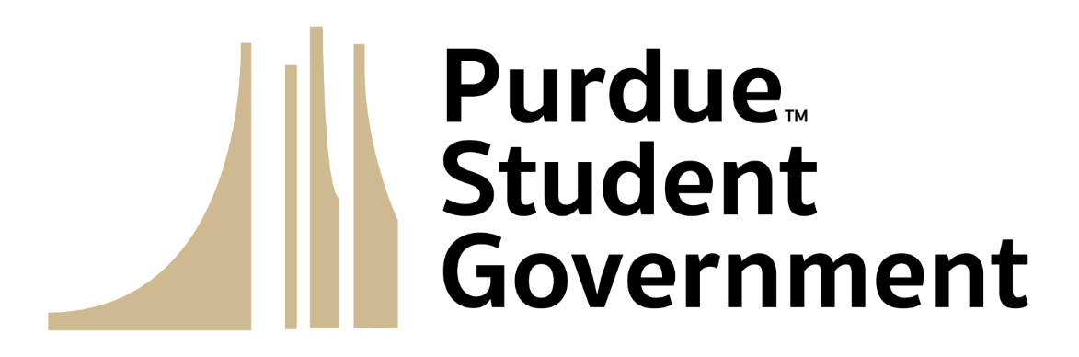
Purdue Student Senate
Session 8
November 1, 2023

- Special Programming
- Call to Order
  - Proxy Reports
  - Roll Call
  - Introduction of Visitors
  - Land Acknowledgement
  - Pledge of Purpose
  - Approval of Minutes
- Executive Reports
  - Cabinet Reports
  - Standing Committee Reports
  - Ad Hoc Committee Reports
  - Advisor Reports
- Informal Discussion
- Old Business
- New Business
  - Bill 23-34 “Implementation of the Student Ideas and Issues Reporting Survey (SIRS)"
  - Bill 23-35 “Experimental Bike Rack Initiative (EBRI)"
  - Resolution 23-02
- Announcements
- Adjournment

